# Supply Chain Contracts at SkiRetail

Case prepared by:

Rajesh K Tyagi, Assistant Professor

HEC Montréal

Montreal, Quebec, Canada

Email: [rajesh-kumar.tyagi@hec.ca](mailto:rajesh-kumar.tyagi@hec.ca)

and

Navneet Vidyarthi, Assistant Professor

John Molson School of Business

Concordia University

Montreal, Quebec, Canada

Email: [navneetv@jmsb.concordia.ca](mailto:navneetv@jmsb.concordia.ca)

# INTRODUCTION

John Bergard sat behind his desk staring out of the large glass window in his office in Aspen, Colorado on a cold Tuesday morning. The view of the Rockies was breathtaking. “This is indeed a great place to work,” thought John. As he sipped his warm coffee, he began to focus his thoughts on his upcoming meeting on Friday with SkiRetail, an upscale fashion retailer in Aspen.

Bergard had joined Skiekz only a month ago, after graduating from HEC Montréal with a specialization in logistics and supply chains. He was in charge of designing sales as well as purchase contracts for the company’s newly opened operations in Aspen. He reported to Mark Bayer, who was the Chief Operating Officer at Skiekz, Aspen.

Friday was a big day for Bergard. He was scheduled to meet with the purchase manager at SkiRetail. The retailer would place an order for Skiekz’s ski jackets for the upcoming winter season on Friday. Bergard, accompanied by the head of marketing, had to convince the retailer to buy more of their products. SkiRetail was a well-established retail firm and Bergard knew that he had to back up his arguments with strong numbers if he was to stand a chance of convincing the team at SkiRetail to purchase more of Skiekz’s jackets.

Bergard knew that he would need to draw on his five years of supply chain experience with a retail giant in the US as well as on his education in logistics and supply chains. “Well,” he thought to himself, “let’s take it one step at a time.” He prepared to leave for a meeting that was scheduled with the marketing team in ten minutes.

# SKIEKZ

Skiekz designs, manufactures and distributes stylish ski wear to high-fashion retailers in Switzerland. The company was founded in 2001 in Switzerland by Chris Adler, an avid ski and business enthusiast and a fashion designer by training. Adler’s designs were highly regarded for their style as well as their functionality. By 2010, Skiekz was a formidable brand and a leading manufacturer of high-fashion ski wear in Switzerland.

The selling season for Skiekz’s products typically began in November and lasted until January. The design process for the subsequent winter season would begin about ten months in advance. Adler would complete the initial designs for the subsequent selling season by March and share them with the manufacturing department. The initial prototypes would then be created and an exhibition would be held to showcase the prototypes to the high-fashion retailers of Switzerland. Adler would incorporate any suggestions provided during the exhibition and finalize the designs. A prototype of the final design would then be sent to all the retailers, along with an invitation to place an order for the quantities they wished to purchase. The retailers would then provide their order quantities based on inputs from their marketing departments by July. Skiekz would then go into production for the different orders received from the retailers by the beginning of August. The manufacturing process, including the sourcing of raw materials, took 75 days. Skiekz would ship all the orders by mid-October.

Skiekz manufactures a variety of ski wear products, including pants, jackets, shells, vests, sweaters and other accessories. Jackets accounted for 78% of its total revenues, sweaters for 12% and the other products for the remaining 10% of the company’s revenues (see Appendix 1).

In 2013, Skiekz expanded operations into the United States of America, with a first location in Aspen. Adler sensed a great business opportunity in the expansion, since he was convinced that European fashion products were highly regarded in the United States. The strategy of the company would remain the same. Adler and his team would design the products; Skiekz would manufacture the ski wear products locally and sell the merchandize through upscale high-fashion retail outlets in the region. Skiekz was interested in doing business with a well-established fashion retailer called SkiRetail. It was the norm at Skiekz that the manufacturer would ship products only in batches of 1,000 units. Aspen would be no exception.

# 11:00 A.M., Skiekz Office, Aspen

John Bergard walked back into his office from the just-concluded meeting with the marketing team. Bergard had asked for specific inputs from the marketing team about forecasts for jackets, as his meeting on Friday was to be centred on the finalization of the strategy for jackets with SkiRetail. Subsequent meetings in the following week were scheduled for a discussion of other Skiekz products.

Bergard reviewed all the information he had thus far. Paul Archer, the head of marketing, had told him that the expected price at which Skiekz could sell to SkiRetail was $200. Archer had also provided him with market intelligence reports containing the historical demand for high-fashion ski jackets at SkiRetail (see Appendix 2). He had told Bergard that he expected the retailer to sell the jackets for $250 apiece. Bergard had learned from the production team that it would cost Skiekz $140 to produce one unit of the jacket. Additionally, the company would have a fixed cost of $70,000 to cater to the production for the upcoming season.

Bergard knew that it is difficult to predict demand for high-fashion goods. “People either like the design that season or they don’t. It’s as simple as that,” he thought. He knew that SkiRetail did not want to get stuck with too much unsold inventory. SkiRetail would have to sell all the jackets not sold within the season to discount retailers for $60 apiece. SkiRetail had seemed optimistic about the new designs when they had been shown the prototypes and Bergard knew that the retailer would not want to lose out on sales opportunities by placing an order for too small a quantity either. But how could he coax them to buy more? Bergard heard himself say aloud, “First, I’ll need to figure out what SkiRetail would consider as the optimal quantity, given what I know.”

Bergard had learned from his experience and his supply chain classes that, often, there is a lot of unclaimed value left behind in the supply chain when entities within the supply chain tend to optimize their own individual profits. “I need to calculate the maximum profits that could be drawn from the supply chain, and the best way to calculate this is by considering the supply chain as one vertically integrated unit. That way, I will be able to find the global optimum profit levels for the entire supply chain.” He recollected a lecture from one of his classes: “The global optimum profit levels are much higher than the aggregate sum of profits when individual entities in the supply chain tend to maximize their individual profits.”

“Once I estimate the optimal order quantity for SkiRetail, I’ll be able to figure out how much value is left unclaimed in the supply chain by calculating the global optimum profit levels.” Obviously, higher profit levels can be achieved only through more sales, which would mean that SkiRetail would purchase more units than what it believed was the optimal quantity. “This unclaimed value is what I would need to take advantage of, if I need to convince the guys at SkiRetail to buy more than what they think is optimal,” Bergard thought.

He pondered a discussion he had had with his professor a few months earlier. He recalled that supply chain contracts were a method to capture the unclaimed value left behind in the supply chain. He had learned that firms were willing to buy more if risks were shared and that supply contracts help firms share risks and potential benefits. Bergard reached for his notes and browsed through them. Finally he opened a page which read:

There are several types of supply contracts that a manager could enforce to share both potential risks and benefits with suppliers:

1. **Buy-back contracts**

In this type of contract, the manufacturer agrees to buy back unsold goods from the retailer for some agreed-upon price higher than the salvage value.

1. **Revenue-sharing contracts**

In this type of contract, the manufacturer shares a percentage of the revenues earned by the retailer. In return, the manufacturer reduces the unit price at which the retailer would be required to buy from the manufacturer.

Just as Bergard was finishing reading his notes, Bayer walked into his office and said, “Hi John. How is everything coming along?” Bergard briefed Bayer about all that he had learned. “That makes a lot of sense. But John, let’s say we propose the buy-back contract. That would mean that we would have to buy back the entire unsold inventory from SkiRetail. Wouldn’t that hurt our profits instead of raising them?” Bergard was quick to respond: “Well Mark, it would also induce SkiRetail to buy more. So you see, we can increase our revenues as well.”

“I will have to see the numbers. Can you tell me what buy-back price we would have to offer to SkiRetail to result in increased profits for us? Of course, this scenario has to increase SkiRetail’s profits as well. Why else would they consider it otherwise? And as for the revenue-sharing model, what do you think is the optimal price at which we should sell the jackets to SkiRetail? I spoke to Paul this afternoon and he told me that SkiRetail could agree to a revenue–sharing deal of 15% from regular sales. They would be unwilling to share their revenues from discount retailers. Can you brief me on these points by tomorrow? I’d like to know your recommendation as well so that we can finalize our strategy before your meeting with the team at SkiRetail.”

“Sounds good!” Bergard responded, “I’ll run them by you tomorrow Mark.”

“Great!” said Mark. “See you tomorrow then.”

Bergard quickly made a list of the questions he needed to answer for his meeting with Mark the next day:

1. What is my estimate of the quantity of ski jackets that SkiRetail should place an order for?
2. What is the global optimum profit level in this case? In case of a buy-back contract, since we will buy up the unsold inventory from SkiRetail, there would be no additional revenue from third-party discount retailers. However, in the case of the revenue-sharing model, additional revenue would flow into the supply chain from third-party discount retailers. In that case, will the global optimum profit levels remain the same? How should I account for the difference?
3. In the case of a buy-back contract, what is the optimal buy-back price Skiekz should propose?
4. In the case of a revenue-sharing contract, what is the optimal sales price Skiekz should propose, given that SkiRetail is willing to share 15% of its revenues from regular sales?
5. Should I recommend a buy-back contract or a revenue-sharing contract? Why? What are the potential benefits and risks associated with each?

Bergard knew that he had to supplement each of his arguments with concrete data in order to convince Mark and devise an effective contract for SkiRetail.

**APPENDIX 1**

Revenue Breakdown

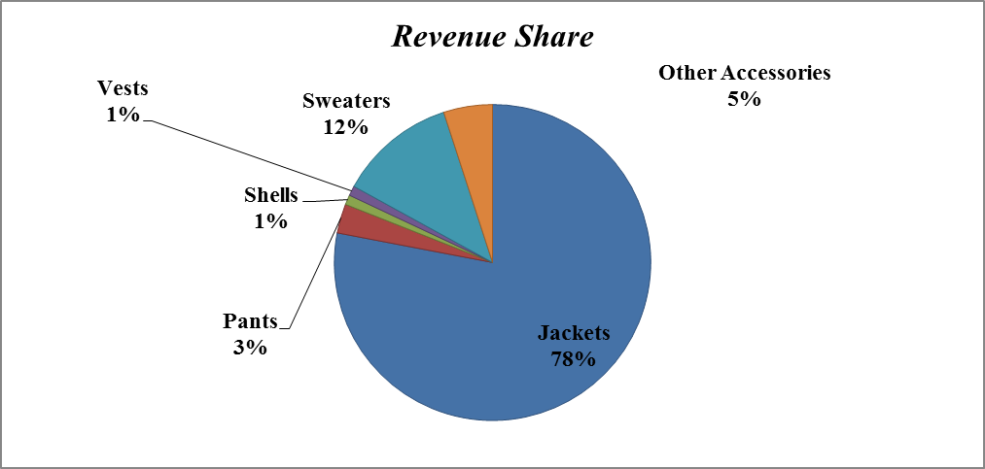

**APPENDIX 2**

Observed Demand

